 

Sarcasm Detection

A Project on Human Behavior

Personality Predictor

Submitted to: Yogendra Sir

Submitted by: Tapan Vijayvergiya & Vikas Sharma

TABLE OF CONTENT

* Certificate
* Acknowledgement
* Abstract
* List of figures
* Introduction
* Theory
* Methodology
* Data Pre-processing
* Classification Methods
* Result Analysis
* QR code to github’s source code page
* Annexure

**Certificate**

Date: 27/06/19

This is to certify that Mr. **Digvijay Singh**, student of 3rd Year from Department of Computer Science, Anand International College of Engineering, Jaipur, has undergone a Project work from May 29, 2017 to July 05, 2017 in **Data Science & Machine Learning** titled “**Sarcasm Detection**”.

_____________ ______________

Project In charge Seal

**Certificate**

Date: 27/06/19

This is to certify that Mr. **Sourabh Prajapati**, student of 3rd Year from Department of Computer Science, Anand International College of Engineering, Jaipur,has undergone a Project work from May 29, 2017 to July 05, 2017 in **Data Science & Machine Learning** titled “**Sarcasm Detection**”.

_____________ ______________

Project In charge Seal

**Acknowledgement**

For making this project we would like to thank our course instructor, Yogendra Sir and Dr. Sylvester Fernandes. They have helped us in learning the various concepts of the Machine Learning. Here we would also like to thank Kunal Sir, Piyush Sir, Krishna Sir and Dushyant Sir for mentoring us throughout this project.

## Abstract

Rapid growth of data comes with a challenge of sorting and analysing them, where raw data exists in graphical form, textual form or in images. Data science and machine learning finds its application in various fields like stock market, recommendation systems, image processing, aerial photography, military, weather forecasting etc.

This report is about our project on “Sarcasm Detection” that addresses about data pre-processing and post processing which includes classification and prediction of human personality in real time and the ability of machine learning algorithms to deal with different set of data. In this project, we have tackled a classification problem of predicting whether a given statement is sarcastic or not from given news headlines data. We have tested and used Linear SVC, Logistic Regression, Decision Tree, k-Nearest Neighbors, Random forest, Naive Bayes and XGBoost Classifier to determine the results. In addition to this, we have also made use of Natural Language Processing (NLP) to process textual data.

## List of Figures

Fig. 1 .…………………………………… Sarcasm definition

Fig. 2 ……………………………………. Data Science

Fig. 3 ……………………………………. Decision Tree

Fig. 4 ……………………………………. Logistic Regression

Fig. 5 ……………………………………. Linear Regression

Fig. 6 ……………………………………. kNN

Fig. 7 ……………………………………. DataFrame.head()

Fig. 8 ……………………………………. WebApp for Personality Prediction UI

Fig. 9 ……………………………………. Scores of different models

Fig.10 ……………………………………. Prediction User-Interface

## Introduction

Automatic sarcasm detection is the task of predicting sarcasm in text. This is a crucial step to sentiment analysis, considering prevalence and challenges of sarcasm in sentiment-bearing text. Beginning with an approach that used automatic sarcasm detection has witnessed great interest from the sentiment analysis community. The challenges of sarcasm and the benefit of sarcasm detection to sentiment analysis have led to interest in automatic sarcasm detection as a research problem. Automatic sarcasm detection refers to computational approaches that predict if a given text is sarcastic. thus, the sentence ‘I love it when my son rolls his eyes at me’ should be predicted as sarcastic, while the sentence ‘I love it when my son gives me a present’ should be predicted as non-sarcastic.

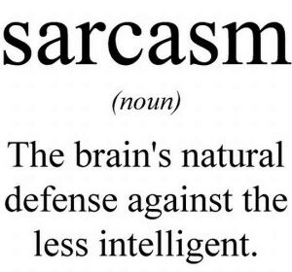

Figure 1: Sarcasm definition

Our approach to the problem is very simple, we first retrieve the dataset that consists of roughly 26,700 features having article Link, headline and is-sarcastic. Then we will check the dataset for some missing data i.e. the data pre-processing part. Then, we move towards data fetching followed by importing features, splitting dataset, applying machine-learning algorithms, classification and finally prediction.

Finally, we compare the performance of each of these algorithms with the help of accuracy matrices, score matrices and then chooses the one that gives more accuracy.

## Theory

Data science is a "concept to unify statistics, data analysis and their related methods" in order to "understand and analyse actual phenomena" with data.[3] It employs techniques and theories drawn from many fields within the broad areas of mathematics, statistics, information science, and computer science, in particular from the subdomains of machine learning, classification, cluster analysis, data mining, databases, and visualization.

Data science – discovery of data insight

This aspect of data science is all about uncovering findings from data. Diving in at a granular level to mine and understand complex behaviours, trends, and inferences. It's about surfacing hidden insight that can help enable companies to make smarter business decisions.

For example:

Netflix data mines movie-viewing patterns to understand what drives user interest, and uses that to make decisions on which Netflix original series to produce

Data science – development of data product

A "data product" is a technical asset that: (1) utilizes data as input, and (2) processes that data to return algorithmically generated results. The classic example of a data product is a recommendation engine, which ingests user data, and makes personalized recommendations based on that data.

For example:

Amazon's recommendation engines suggest items for you to buy, determined by their algorithms. Netflix recommends movies to you. Spotify recommends music to you.

Machine learning, and statistics are part of data science. The word learning in machine learning means that the algorithms depend on some data, used as a training set, to fine-tune some model or algorithm parameters. This encompasses many techniques such as regression, naive Bayes, classification or supervised clustering.

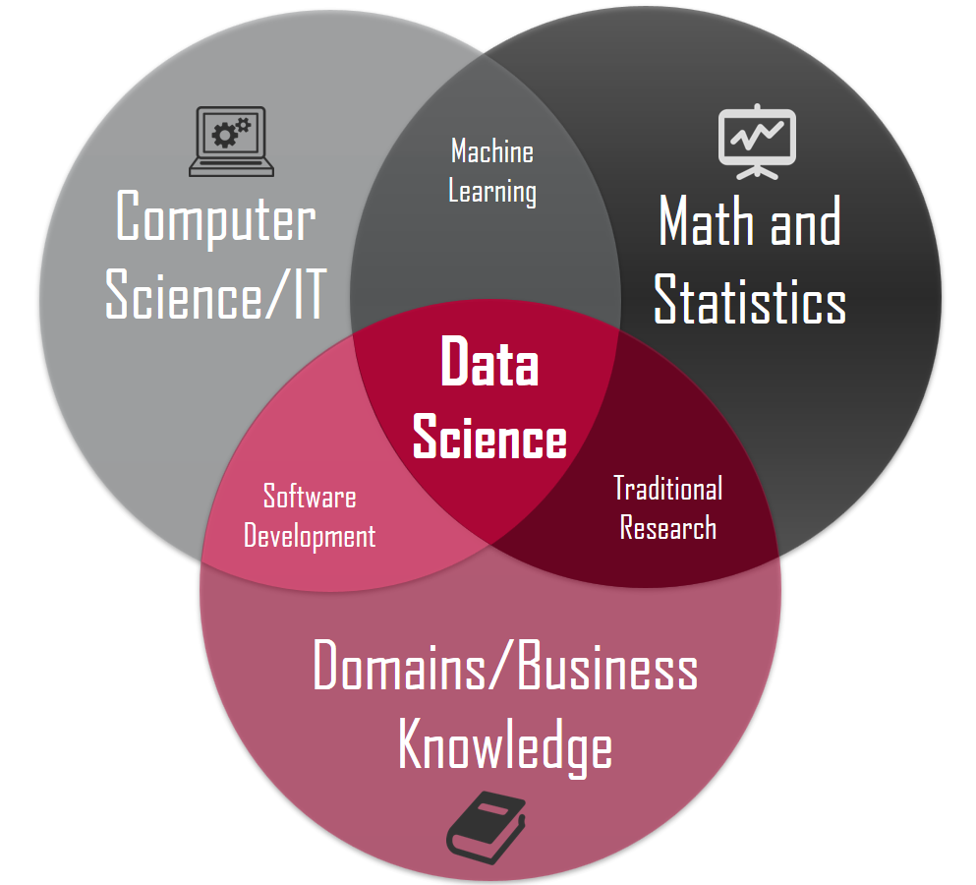

Figure 2:Data Science

Supervised and unsupervised learning describe two ways in which machines algorithms can be set loose on a data set and expected to learn something useful from it.

**Supervised:**

If we are training our machine-learning task for every input with corresponding target, it is called [supervised learning,](https://en.wikipedia.org/wiki/Supervised_learning) which will be able to provide target for any new input after sufficient training. Our learning algorithm seeks a function from inputs to the respective targets. If the targets are expressed in some classes, it is called *classification* problem. Alternatively, if the target space is continuous, it is called *regression* problem.

* **Regression** analysis is widely used for prediction and forecasting, where its use has substantial overlap with the field of machine learning. Regression analysis is also used to understand which among the independent variables are related to the dependent variable, and to explore the forms of these relationships. In restricted circumstances, regression analysis can be used to infer causal relationships between the independent and dependent variables.

* **Classification** model attempts to draw some conclusion from observed values. Given one or more inputs a classification model will try to predict the value of one or more outcomes. Outcomes are labels that can be applied to a dataset.

**Unsupervised:** If we are training our machine-learning task only with a set of inputs, it is called unsupervised learning, which will be able to find the structure or relationships between different inputs. Most important unsupervised learning is *clustering*, which will create different cluster of inputs and will be able to put any new input in appropriate cluster.

* **Cluster** analysis or clustering is the task of grouping a set of objects in such a way that objects in the same group (called a cluster) are more similar (in some sense or another) to each other than to those in other groups (clusters). It is a main task of exploratory [data mining,](https://en.wikipedia.org/wiki/Data_mining) and a common technique for [statistical](https://en.wikipedia.org/wiki/Statistics) [data analysis,](https://en.wikipedia.org/wiki/Data_analysis) used in many fields, including [machine learning,](https://en.wikipedia.org/wiki/Machine_learning) [pattern recognition,](https://en.wikipedia.org/wiki/Pattern_recognition) [image analysis,](https://en.wikipedia.org/wiki/Image_analysis) [information retrieval,](https://en.wikipedia.org/wiki/Information_retrieval) [bioinformatics,](https://en.wikipedia.org/wiki/Bioinformatics) [data compression,](https://en.wikipedia.org/wiki/Data_compression) and [computer graphics.](https://en.wikipedia.org/wiki/Computer_graphics)

1. **Decision Trees:** A decision tree is a decision support tool that uses a tree-like graph or model of decisions and their possible consequences, including chance-event outcomes, resource costs, and utility.

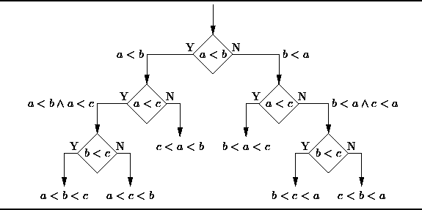

Figure 3:Decision Tree

From a business decision point of view, a decision tree is the minimum number of yes/no questions that one must ask, to assess the probability of making a correct decision, most of the time. As a method, it allows you to approach the problem in a structured and systematic way to arrive at a logical conclusion.

1. **Logistic Regression:** Logistic regression is a powerful statistical way of modelling a binomial outcome with one or more explanatory variables. It measures the relationship between the categorical dependent variable and one or more independent variables by estimating probabilities using a logistic function, which is the cumulative logistic distribution.
   * 1. 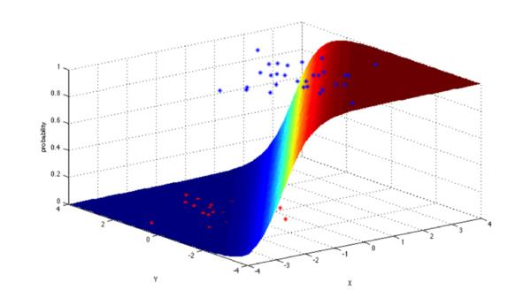

Figure 4:Logistic Regression

1. **Linear Regression**

It is used to estimate real values (cost of houses, number of calls, total sales etc.) based on continuous variable(s). Here, we establish relationship between independent and dependent variables by fitting a best line. This best fit line is known as regression line and represented by a

Linear equation Y = a * X + b.

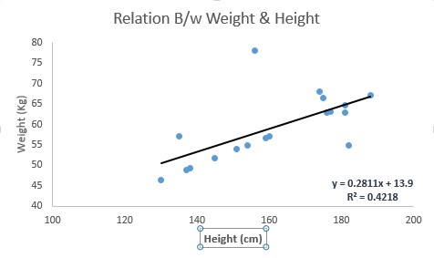

Figure 5:Linear Regression

1. **KNN (K- Nearest Neighbors)**

It is also a lazy algorithm. What this means is that it does not use the training data points to do any generalization. K nearest neighbors is a simple algorithm that stores all available cases and classifies new cases by a majority vote of its k neighbors. The case being assigned to the class is most common amongst its K nearest neighbors measured by a distance function. These distance functions can be Euclidean, Manhattan, Minkowski and Hamming distance. First three functions are used for continuous function and fourth one (Hamming) for categorical variables. If K = 1, then the case is simply assigned to the class of its nearest neighbors. At times, choosing K turns out to be a challenge while performing KNN modelling.

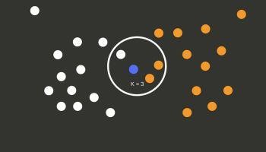

Figure 6:KNN

**5. Naïve Bayes**

Naive Bayes is a collection of classification algorithms based on Bayes Theorem. It is not a single algorithm but a family of algorithms that all share a common principle, that every feature being classified is independent of the value of any other feature. So for example, a fruit may be considered to be an apple if it is red, round, and about 3″ in diameter. A Naive Bayes classifier considers each of these “features” (red, round, 3” in diameter) to contribute independently to the probability that the fruit is an apple, regardless of any correlations between features. Features, however, aren’t always independent which is often seen as a shortcoming of the Naive Bayes algorithm and therefore it’s labelled “naive”.

Although it’s a relatively simple idea, Naive Bayes can often outperform other more sophisticated algorithms and is extremely useful in common applications like *spam detection* and *document classification*.

In a nutshell, the algorithm allows us to predict a class, given a set of features using probability. So, in another fruit example, we could predict whether a fruit is an apple, orange or banana (class) based on its colour, shape etc (features).

**5.XGBoost (Extreme Gradient Boosting)**

XGBoost is an implementation of Gradient Boosting Machines (GBM) and is used for supervised learning. XGBoost (eXtreme Gradient Boosting) can be used for supervised learning tasks such as Regression, Classification, and Ranking. It is built on the principles of gradient boosting framework and designed to “push the extreme of the computation limits of machines to provide a scalable, portable and accurate library.”

**Gradient boosting:**

Gradient boosting is a machine learning technique for regression and classification problems, which produces a prediction model in the form of an ensemble of weak prediction models, typically decision trees. It builds the model in a stage-wise fashion like other boosting methods do, and it generalizes them by allowing optimization of an arbitrary differentiable loss function.

XGBoost is one of the implementations of Gradient Boosting concept, but what makes XGBoost unique is that it uses “a more regularized model formalization to control over-fitting, which gives it better performance. Therefore, it helps to reduce overfitting.

## Problem Statement

Past studies in Sarcasm Detection mostly make use of Twitter datasets collected using hashtag-based supervision but such datasets are noisy in terms of labels and language. Furthermore, many tweets are replies to other tweets and detecting sarcasm in these requires the availability of contextual tweets.

Our task is to train a model by using machine learning algorithms which can predict if a statement is sarcastic or not.

## Methodology

To understand the methodology adopted, we first understand our dataset and the variables.

**Dataset**

Our dataset consists of 26709 observations of news headlines from The Onion and HuffPost website. It consists of three columns Article link, news headline and is_sarcastic. The target is to train a machine-learning algorithm so that it can predict a statement to be sarcastic or not.

**Features:**

* headline – The news headlines is the only feature. The data contains some special symbols like (‘,’, ‘.’, ‘-’).

**Dependent Variables:** is_sarcastic, which shows if statement is sarcastic(1) or not sarcastic(0).

**Independent Variables:** headline.

## Data Pre-processing

For pre-processing, we considered Python as our options for the project. After some experimentation, we found that while R was easier for statistics and analysis of the data but the lack of uniformity among the various ML packages in R made Python our preference.

The ML algorithms provided by the scikit-learn package do not function if the input data has missing values. Hence, we either had to impute data at the missing slots or remove the instances that had these missing fields. Upon examining the data, we realized that in this project we don’t have any missing data but have categorical data that needs to be converted in integer values to make the model work. And to do that we used NLP to process Textual data and to convert to numerical value we used TF-IDFVectorizer().

## Libraries used

* NumPy
* pandas
* re
* pickle
* nltk
* time
* scikitlearn
* sklearn.svm
* sklearn.linear_model
* sklearn.ensamble
* sklearn.neighbors
* flask

## 

## Classification Method Used

Here for making classification of the statement to be sarcastic made by user we used various algorithms like K – Nearest Neighbors, Logistic Regression in Classification mode, Decision Tree Classifier, Random Forest Classifier, SVM, Naïve Bayes but we got the highest accuracy that of 84.04% from the Linear SVC Classifier.

In our primary approach we loaded our csv data file on our pandas data frame. After loading data using dataframe.head() method we took a look at our data.

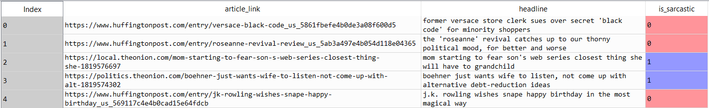

Figure 7:DataFrame head()

As we can see our data contains just plain text, it contains symbols, article links. To prepare the data for prediction we need to clean it up first.

To clean up the data we applied regex using re library and got rid of anything other than words. After completion of cleaning process, we put the data back in our data frame.

**Vectorization of data:**

Since, now our data contains plain text so we can apply some vectorizing to it. We used

*TF-IDFVectorizer() from* *sklearn.feature_extraction.text* to convert our data into numerical vectors . The TF-IDFVectorizer provides a simple way to both tokenize a collection of text documents and build a vocabulary of known words, but also to encode new documents using that vocabulary.

Approach 1: -

Now we split our data into features and labels using pandas method, after that we run *train test split* to split our data into separate test and training datasets.

Now using kNN, logistic regression, naïve Bayes, Linear SVC and Random Forest classifier we fit our model onto our training data.

Our simple model is only able to classify statements with a 67% of right

guesses, which is not too much. The highest score was achieved by logistic regression that of 68% which is very low.

Approach 2: -

In our secondary approach, In features we kept TFIDF Vectorized headlines and in labels we took is_sarcastic column which consists binary data(0 and 1).

After applying all the usual machine learning algorithms we got the accuracy of 74.08% that is better from before but not good enough for the model to give solid prediction.

To remedy this issue, we used Linear SVC(Support Vector Classifier) classifier.

After fitting the model into Linear SVC classifier our accuracy was at average 84.04%.

At the deployment stage we saved our trained model into a pickle file so it can be used easily for predictions via a User-Interface.



Figure 8: Web App for Sarcasm detection

## Result Analysis

In this part we had to make the classification of the statements to be sarcastic or not, so here we had used Linear SVC Classifier to classify statemenst and on the test dataset we got the accuracy of 84.04 % for the average of labels that we predicted.

|  |  |  |  |  |  |
| --- | --- | --- | --- | --- | --- |
| Model | KNearestNeighbors | Logistic Regression | Naive Bayes | LinearSVC | RandomForestClassifier |
| Prediction | 68.3% | 78.08% | 75.09% | 84.04% | 79.64% |

Figure 9: Accuracies of different models



Figure 10: Model Prediction

## Conclusion

By Training the model with Linear SVC classifier, we were able to correctly predict the statement to be sarcastic or not with the accuracy of 84.04 %.

## References

WE referred to the documentations from Pandas, Matplotlib and NLTK.

The dataset was taken from Kaggle.